

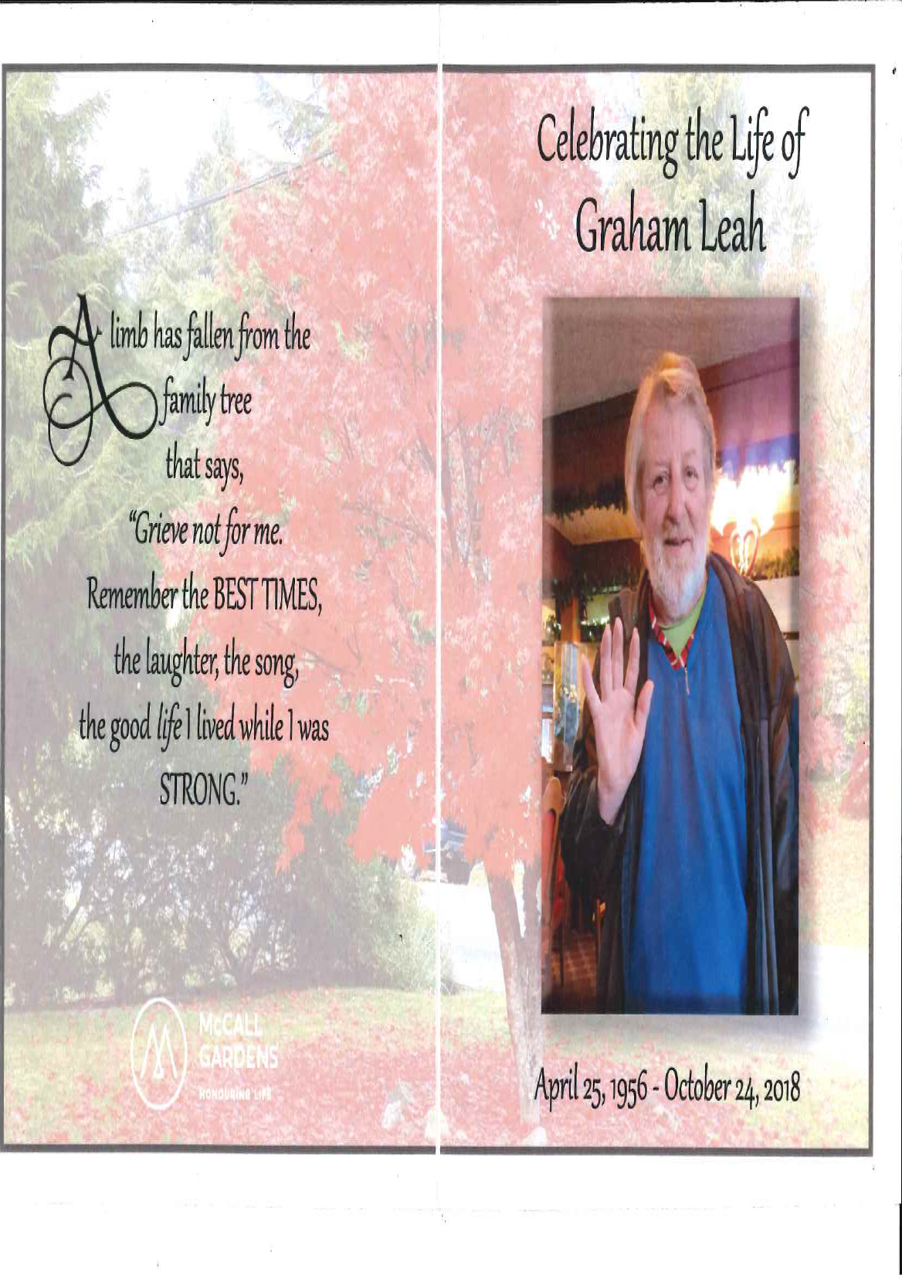

Memorial and Thanksgiving

to celebrate the life of

Graham Leah

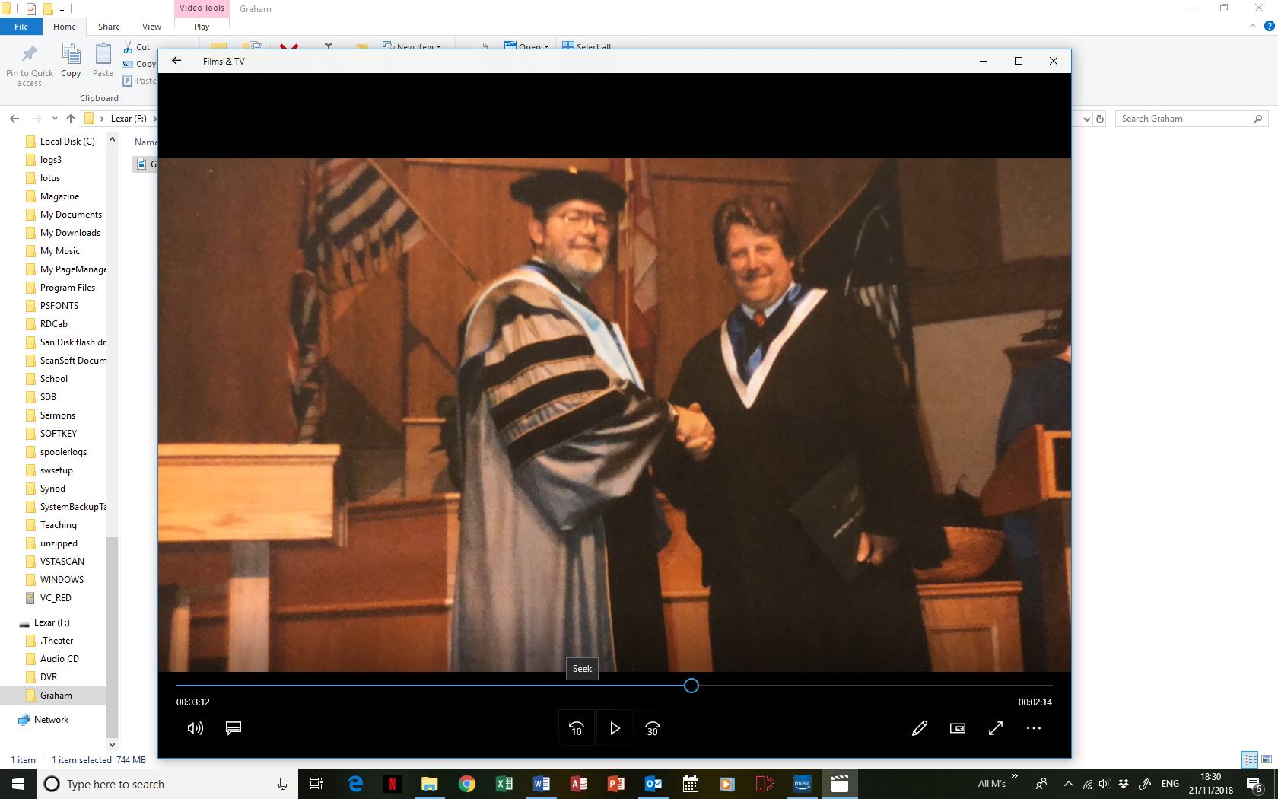

25th April 1956 – 24th October 2018